ELEC-3800

Random Signals and Systems

FROM: Jacob Howard

TO: Prof. Stan Reeves

DUE DATE: 2/18/22

Project 2

# **Introduction**

In this project, we were to run simulations in Matlab using the rand() function. There were six tasks given to us, although task one was just to input code required for all tasks. We were to code in Matlab plot graphs of the random numbers.

# **Exercise 2**

In step 2 we were told to write code using the rand() function to generate 200 random numbers and create a 10 bin histogram of the numbers. The code can be seen in *Code 1*. The graph can be seen in *Figure 1*.

Question: What is the expected shape of the histogram based on the shape of the density function of the random number generator? Why does the plot vary from its expected shape?

Answer: The expected shape was a bell curve with most values showing in the middle. I believe the pot varies because not enough variables were generated.

|  |
| --- |
| %% Part 2calculate 200 random numbers  x = rand(1, 200);  figure(1)  subplot (3, 2, 1); %part b  hist (x, 10); %10 bin histogram |

*Code 1*

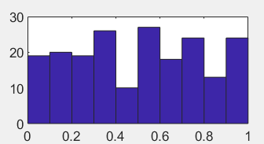

*Figure 1*

# **Exercise 3**

In part 3, we were asked to run the same task as task 1 but with 2,000,000 random numbers. The code can be seen in *Code 2* and the Graph can be seen in *Figure 2.*

Question: How does the bar plot change from the exercise above? Why?

Answer: The bar graph on this experiment came up as all filled as the histogram was too small. We would need a larger histogram to plot this graph.

|  |
| --- |
| %% Part 2calculate 200 random numbers  x = rand(1, 200);  figure(1)  subplot (3, 2, 1); %part b  hist (x, 10); %10 bin histogram |

*Code 2*

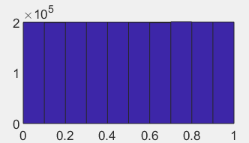

*Figure 2*

# **Exercise 4**

In task 4, we were asked to run the experiment with randn() generating 2,000,000 random numbers, and plotting them in 30 bins. The code can be seen in *Code 3* and the graph in *Figure 3.*

Question: What is the shape of the histogram?

Answer: The shape is a bell graph which is expected.

|  |
| --- |
| %% Part 2calculate 200 random numbers  x = rand(1, 200);  figure(1)  subplot (3, 2, 1); %part b  hist (x, 10); %10 bin histogram |

*Code 3*

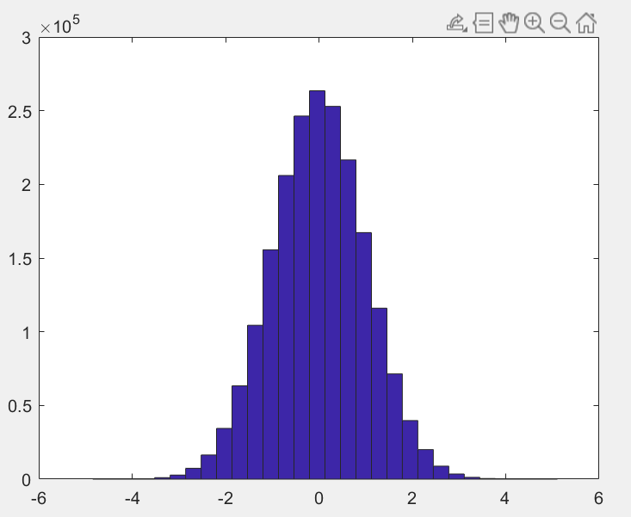

*Figure 3*

# **Exercise 5**

For part 5, we were asked to generate 2,000,000 random numbers using randn and then multiply each number by 3 and then add 4. The code can be seen in Code 4 and the graphs for part 5 can be seen in *Figures 4, 5, and 6.*

Question: Describe the change compared to the result of #4. Explain any differences you observe. How much does the variance change as a result of multiplying by 3?

Answer: When multiplying by 3, the graph got wider. It changes by more than double.

|  |
| --- |
| %% Part 5  a = randn(1, 2000000);  figure(4)  hist (a, 30); %histogram of 30 bins  a = a*3; %multiplying a by 3  figure(5)  hist (a, 30); %histogram of 30 bins  figure(6)  a = a+4; |

*Code 4*

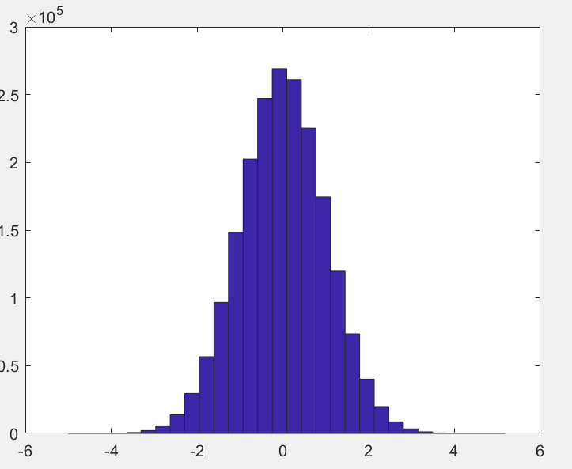

*Figure 4 (original)*

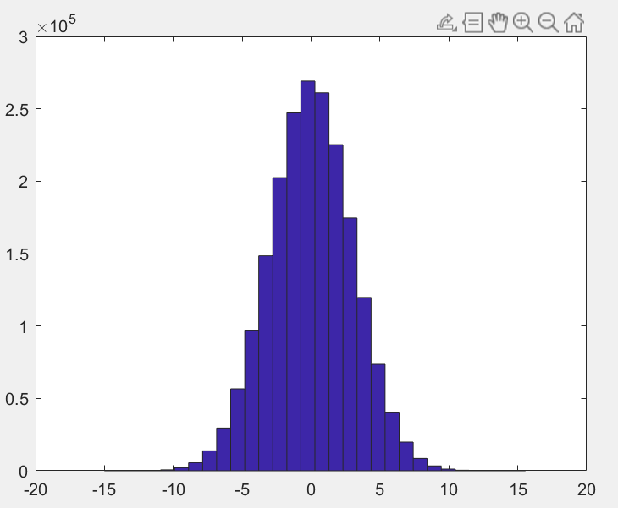

*Figure 5 (x3)*

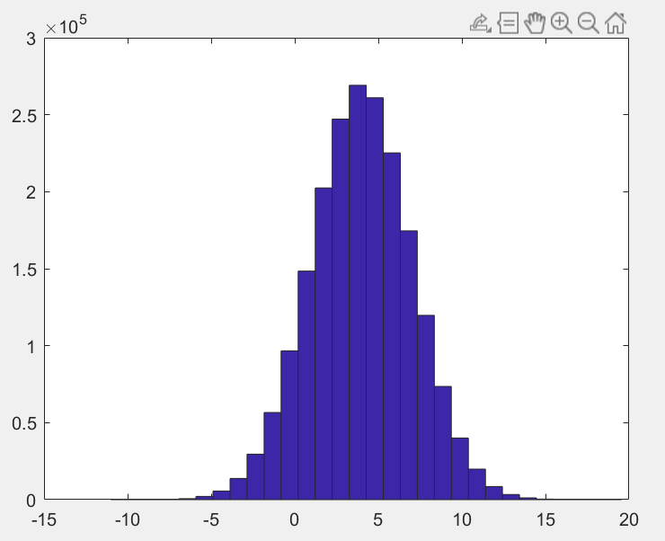

*Figure 6 (+4)*

# **Exercise 6**

In exercise 5, we were asked to generate a set of 2,000,000 random values in the range (0,1) using rand. Then we were asked to transform the variable by computing the following function of the input: *y = sqrt(-2*log(1 - x));*

The code can be seen in *Code 5* and the graphs produced can be seen in *Figures 7 and 8.*

Question: Look at the 100-bin histogram of the input and the 100-bin histogram of the transformed values. Do they look the same or similar in shape?

Answer: For my 2 graphs, no they do not look the same. The second graph came out as a straight line.

|  |
| --- |
| %% Part 6  b = rand(1, 2000000, 0); %2 million random variables between 0 and 1  figure(7)  hist (a, 100);  figure(8)  c = sqrt(-2*log(1 - b));  hist (c, 100); |

*Code 5*

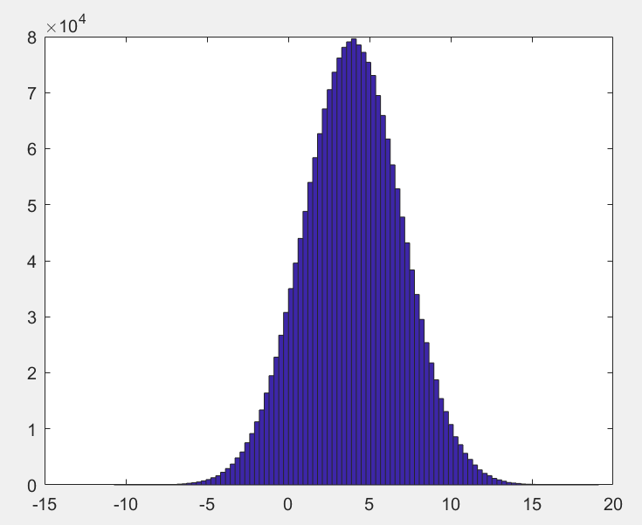

*Figure 7*

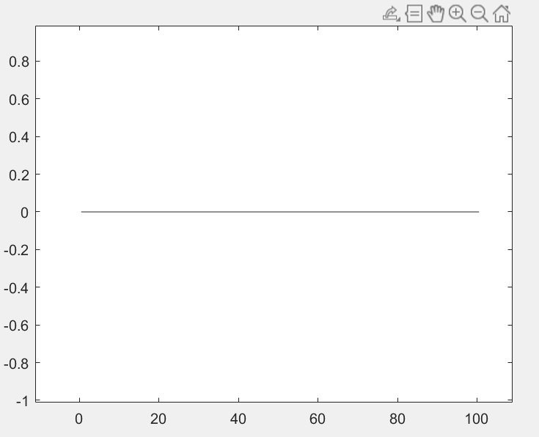

*Figure 8*